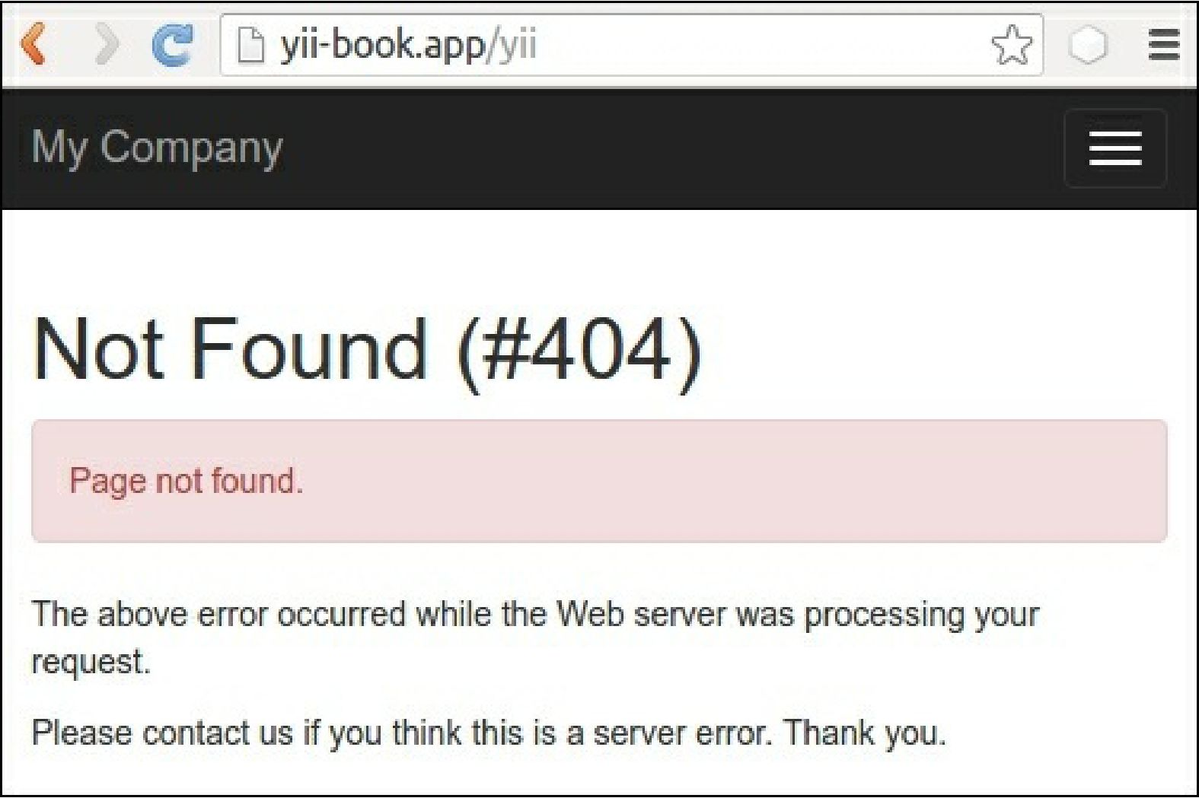

6. Also, check that the framework displays the Internal Server Error exception for our actionFail:

